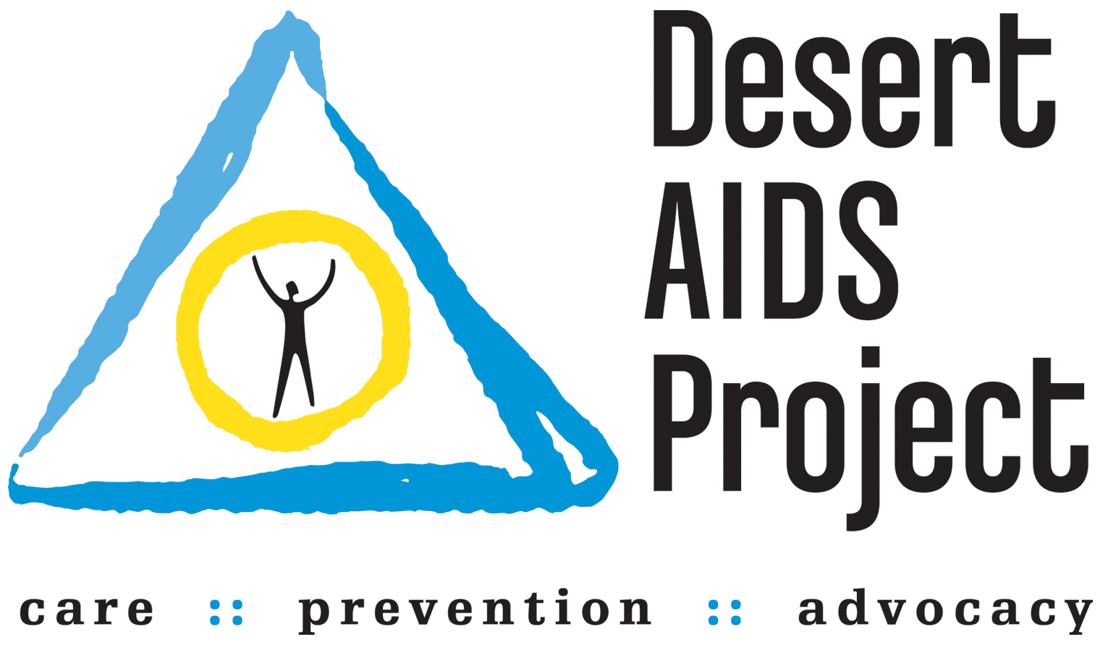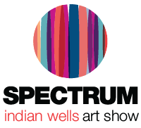

FOR IMMEDIATE RELEASE
Media Contact:
Jaclyn Walian
Olive PR Solutions, Inc.
m. 619-772-5602 o. 619-955-5285
jaclyn@oliveprsolutions.com

Spectrum Indian Wells Partners with Local Non-Profits for Contemporary Art Show Running March 16–19, 2017
-Second annual four-day art event collaborates with non-profits to give back to the community-

INDIAN WELLS, CA (February 21, 2017) – Spectrum Indian Wells, with presenting sponsor UBS Financial Services, is a four-day contemporary art experience featuring top galleries, art publishers, and established studio artists from across the U.S. and around the world, along with art talks, special entertainment, and curated projects. The show will run from Thursday, March 16 to Sunday, March 19, 2017. This year, Spectrum Indian Wells is partnering with two local non-profits, the Desert AIDS Project and Big Brothers Big Sisters of the Desert, to not only give back to the community but also incorporate the community into the lively art world of the Coachella Valley.

“We had such great support from the community last year that this year we wanted to figure out a way to incorporate them even more,” said Eric Smith, president and CEO of Redwood Media Group, which owns and operates Spectrum Indian Wells. “The Desert AIDS Project and Big Brothers Big Sisters of the Desert are fantastic organizations that really care about the community, so we are excited to give back to them.”

Saturday, March 18, has been designated as the Big Brother Big Sisters of the Desert Day at the show. Bigs will get to bring their Littles to the show for a “meet the artists” event, including lunch and an art session with the exhibiting artists. Bigs and Littles will get an up-close-and-personal experience with the artists and even create a piece of art to take home. During the evening, Spectrum Indian Wells will host a reception for the Bigs, during which they will get a chance to socialize, have a glass of wine, and meet an international slate of artists and gallerists.

Big Brothers Big Sisters of the Desert opened its doors in 1996 and has since been helping the children in the community. Their mission is to help children reach their potential through professionally supported, one-to-one relationships with mentors. They serve children throughout the Coachella Valley, ages 6 through 18, in two distinct programs: Community Mentoring and Site-Based Mentoring. Over the past three years, the program has grown by 153 percent and has been recognized nationally for its accomplishments by Big Brothers Big Sisters of America.

“I know that our Littles are going to love going to an art show and learning from the talented artists at the show,” said Judy Tobin May, executive director of Big Brothers Big Sisters of the Desert. “We are also really excited to treat our Bigs to a fabulous reception, as they are so deserving. Partnering with Spectrum Indian Wells is a big win for everyone!”

The opening night preview party on Thursday, March 16 will benefit the Desert AIDS Project. Spectrum Indian Wells is supporting the Desert AIDS Project with an exhibition booth at the show to represent the artists in their Art Gallery Program. The Art Gallery Program started in 2016 as part of the Personal Development and Wellness services they offer their clients.

Since 1984, Desert AIDS Project has been the Coachella Valley resource for those living with, affected by, or at risk for HIV or AIDS. It is a Federally Qualified Health Center that offers primary care, HIV and hepatitis specialty care, dentistry, and behavioral health, all under one roof.

“Our clients involved in the Art Gallery Program are so excited to show off their work and be included in the show’s programming,” said Valerio Iovino, career building coordinator of Desert AIDS Project. “The feature as the Opening Night Preview Party’s beneficiary will help highlight the importance of the Art Gallery Program as an integral part of our mission.”

Tickets for the Spectrum Indian Wells Opening Night Preview Party are priced at $50 online and $60 at the door. General admission tickets are $20 online and $30 at the door. Free general admission will be granted to anyone with a ticket to the BNP Paribas Open. For more information on Spectrum Indian Wells, please visit www.spectrum-indianwells.com.

###
SHOW HOURS:
Opening Night Preview Party
Thursday, March 16, 2017 | 5 p.m. – 8 p.m.

Open Show Days:
Friday, March 17, 2017 | 12 p.m. – 8 p.m.
Saturday, March 18, 2017 | 12 p.m. – 7 p.m.
Sunday, March 19, 2017 | 11 a.m. – 5 p.m.

VENUE:
Renaissance Indian Wells Resort & Spa
44400 Indian Wells Lane
Indian Wells, CA 92210

ADMISSION COST:
Opening Night Preview Party: $50 online | $60 at event
Opening Night Preview Party plus three-day pass : $75 online| $85 at event
General Public: One-day pass $20 online | $30 at event
Three-day pass $25 online | $35 at event
Student/Senior: One-day pass $10 online | $15 at event
Three-day pass $15 online | $20 at event
Children (up to age 15): Free

About Spectrum Indian Wells
Spectrum Indian Wells, which launched its premiere in March 2016, aims to reach hundreds of thousands of art fans via exhibition, education, and special events. Taking place in Indian Wells, California, Spectrum Indian Wells brings a much-needed arts-and-culture element to an area and time of year rich with sporting events, cultural happenings, and music festivals. The four-day contemporary art show is owned and produced by Redwood Media Group (RMG). For more information, visit www.spectrum-indianwells.com.

About Redwood Media Group
Since 2009, Redwood Media Group (RMG) has been revolutionizing the global fine art community by helping artists and gallery owners grow their businesses through fine art exhibitions and publications, art business education, mentoring, marketing, and social media. Today, RMG owns and operates six fine art shows: Artexpo New York, Spectrum Miami, Art San Diego, Spectrum Indian Wells, Art Santa Fe, and Red Dot Miami. Artexpo New York, the world's largest fine art trade show for 39 years and counting, attracts more than 30,000 art enthusiasts every year, including 4,500 industry buyers. Spectrum Miami and Red Dot Miami attract more than 38,000 art aficionados during Miami Art Week, an annual attraction that draws over 100,000 art collectors to the city. Over the past seven years, RMG has welcomed hundreds of thousands of visitors to their events, sold millions of dollars' worth of art, and helped thousands of unrepresented and established artists launch or grow their careers. Aside from hosting multiple high-end art shows throughout the year, RMG also owns Art Business News and DECOR Magazine.

For more information, visit:
www.redwoodmg.com, www.artbusinessnews.com, www.artexponewyork.com, www.art-sandiego.com, www.spectrum-miami.com, www.spectrum-indianwells.com, www.artsantafe.com, and www.reddotmiami.com.

